****CASCADE Asset Management System****

**Design Document, SOW 1 – CFPB Functionality**

**February 2, 2013**

Personalized to



Developed by



**Mined Systems Inc.**

**Metrics Intelligence ©**

Table of Contents

Table of Figures i

Documentation Change Log ii

Executive Summary 1

1 Agency – CFPB Complaint Tracking 2

1.1 User Access 2

1.1.1 Left Navigation 2

1.1.2 Top Navigation 2

1.2 CFPB Complaint Drop Down 2

1.3 Add New Consumer Complaint 3

1.3.1 Agency Add Complaint Search Screen 1 Fields 3

1.3.2 Agency Add Complaint Search Screen 2 Fields 5

1.3.3 Agency Add New Consumer Complaint “Table Grid” Summary Fields 7

1.4 New Complaint Requiring Action 8

1.5 New Complaint in Progress 8

1.6 Awaiting Additional Information 9

1.7 Submitted for Owner Action 9

1.8 Owner Response in Progress 10

1.9 Resolved Complaint 11

2 Roles and User Access 12

2.1 Cascade User 12

2.2 Agency User 12

# 

# Table of Figures

Figure 1: Agency Complaint Search Screen 1 of 2 3

Figure 2: Agency Complaint Search Screen 2 of 2 4

Figure 3: Agency New Complaint Requiring Action 7

Figure 4: Agency New Complaint Requiring Action 8

Figure 5: Agency New Complaint in Progress 9

Figure 6: Agency Awaiting Additional Information 9

Figure 7: Agency Submitted for Owner Action 10

Figure 8: Agency view of Owner Response in Progress 10

Figure 9: Agency Resolved Complaints 11

# Documentation Change Log

(Identifies significant changes only)

|  |  |  |  |
| --- | --- | --- | --- |
| **Version #** | **Change Date** | **Section** | **Change Description** |
|  |  |  |  |
|  |  |  |  |

# Executive Summary

The Consumer Finance Protection Bureau (CFPB) is a Federal Agency with the Department of the Treasury that provides mandatory tracking and compliance requirements for the owners of consumer debt regarding the debt collection practices currently in use by Collection Agencies across the country. As a result, the Debt Owner (in our case it is our customer – Cascade) must have the means to capture, monitor, track and report on any complaint information received from the debtor regarding the debtor’s account. This disputes or complaints by the debtor may or may not be legitimate, but the debt owner (Cascade) must track each complaint from the identification of the complaint through to the completion and resolution of the complaint with the debtor.

This functionality is being built into the existing Cascade Asset Management application as another “module” called “Compliance” since there may be other forms of compliance that Cascade will need to monitor and report on in the future.

The following sections of this document provide the detailed information regarding the purpose, fields, and functions of the CFPB complaint tracking functionality.

The “navigational flow” of this functionality can be seen in the corresponding PDF mockup document(s) that have been provided separately.

# Agency – CFPB Complaint Tracking

This existing Cascade Asset Management System will be enabled to support the “Compliance” module so that Complaint information coming from the debtor can be captured, tracked, and resolved to the debtor’s [and the debt owner’s] mutual satisfaction. The following subsections will describe the navigational “flow” and the fields of data that will be shown on the corresponding UI screens and reports.

## User Access

When the “Agency user” logs into the Cascade Asset Management System, they will see a “limited” set of functionality as depicted in the mockup. The following left-navigation and top-navigation items will be available to them.

### Left Navigation

#### Advanced Search

This function will enable the Agency user to find any records associated with their Agency ONLY, using the search elements available within the “Advanced Search” feature.

#### Reports

The “Collections” and the “Compliance” reports will be available for the Agency user to find any records associated with their Agency ONLY.

#### My Account

This functionality will enable the Agency user to perform such functions as changing their password, send email, create email groups and send meeting invites.

#### My CRM

This functionality will enable the Agency user to perform CRM functions to track and manage their customers, contacts, and opportunity pipeline.

### Top Navigation

#### Collections

This functionality will enable the Agency user to provide the necessary data regarding their collection activities on their assigned accounts.

#### Compliance

This functionality will enable the Agency user to capture compliant information from the debtor [or from the debt owner on behalf of the debtor] and to track, monitor, and resolve the complaint to the mutual satisfaction of the debt owner and the debtor.

## CFPB Complaint Drop Down

When logging in, the Agency user will “mouse-over” the “Compliance” module button and will see the “CFPB Complaints” option. When “mousing-over” the “CFPB Complaints” option, the Agency user will see the following options, each explained in the following sub-sections:

* Add New Consumer Complaint
* New Complaint Requiring Action
* New Complaint in Progress
* Awaiting Additional Information
* Submitted for Owner Action
* Owner Response in Progress
* ~~Response Submitted to Consumer~~ (this is not needed and will be removed from the mockup)
* Resolved Complaints

## Add New Consumer Complaint

When adding a new complaint, the Agency user will first need to search for and find the applicable account record within PIMS to retrieve the associated data. The user will be presented with 2 screens from which to select certain fields of data to assist with finding the record. The following figures provide screen shots of the two “search” screens.

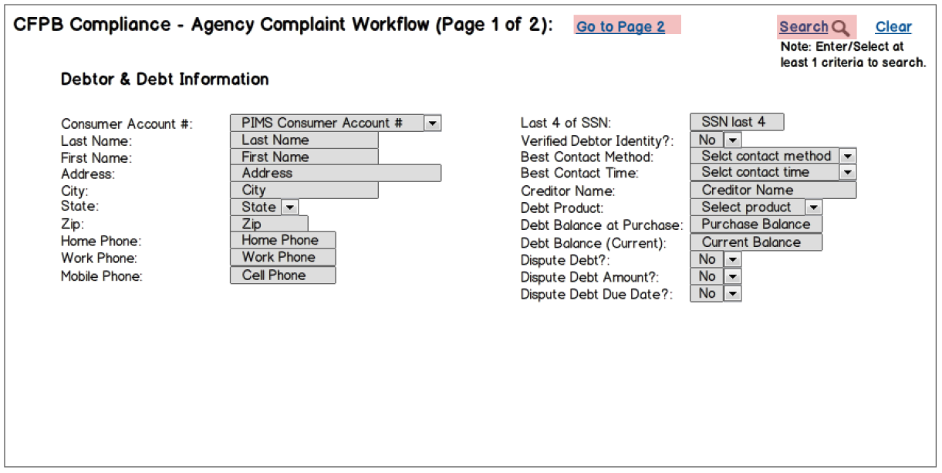

Figure 1: Agency Complaint Search Screen 1 of 2

### Agency Add Complaint Search Screen 1 Fields

* PIMS Consumer Account # - this is a data entry field where the user can enter all [or some] of the PIMS account number. This would be found in vwAccounts\Account
* Last Name – this is a data entry field. This would be found in vwAccounts\LastName
* First Name – this is a data entry field. This would be found in vwAccounts\FirstName
* Address – this is a data entry field. This would be found in vwAccounts\ADDRESS1
* City – this is a data entry field. This would be found in vwAccounts\CITY
* State – this is a DROP DOWN list of the State 2-character abbreviations. This would be found in vwAccounts\state
* Zip – this is a data entry field. This would be found in vwAccounts\ZIP_CODE
* Home Phone – this is a data entry field. This would be found in vwAccounts\PHONE_HOME
* Work Phone – this is a data entry field. This would be found in vwAccounts\PHONE_WORK
* Cell Phone – this is a data entry field. This would be found in vwAccounts\PHONE_CELL
* Last 4 of SSN – this is a data entry field. This would be ONLY the last 4 digits of the SSN and would be found in vwAccounts\SSN
* Verify Debtor Identity? – this is a DROP DOWN field with the values of “Yes” or “No” (default value is “No”). This field would generally NOT be used during the “search” function
* Best Contact Method – this is a DROP DOWN field with the following values (in this order – default value is “blank”):
  + Home Phone
  + Work Phone
  + Cell Phone
* Best Contact Time – this is a DROP DOWN field with the following values (in this order – default value is “blank”):
  + Morning only
  + Afternoon only
  + Daytime only
  + Evening only
  + Weekend only
* Creditor Name – this is a data entry field. This would be found in vwAccounts\CreditorName
* Debt Product – this is a DROP DOWN field with the following values (in this order – default value is “blank”):
  + Credit Card
  + Automobile
  + Mortgage
* Debt Balance at Purchase – this is a data entry field. This would be found in vwAccounts\Balance
* Debt Balance (Current) – this is a data entry field. This would be found in vwAccounts\TOT_DUE_AMT
* Dispute Debt? – this is a DROP DOWN field with the values of “Yes” or “No” [default value is “No”). This field would generally NOT be used during the “search” function
* Dispute Debt Amount? – this is a DROP DOWN field with the values of “Yes” or “No” [default value is “No”). This field would generally NOT be used during the “search” function
* Dispute Debt Due Date? – this is a DROP DOWN field with the values of “Yes” or “No” [default value is “No”). This field would generally NOT be used during the “search” function

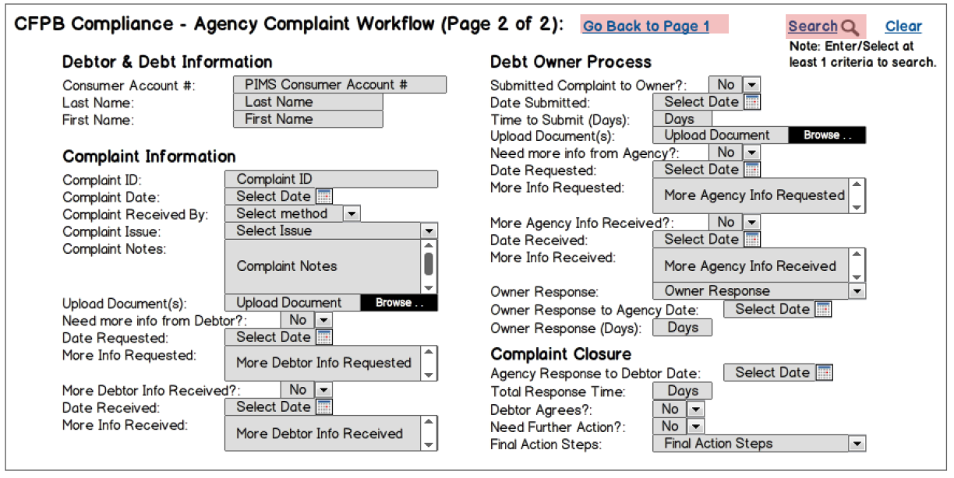

Figure 2: Agency Complaint Search Screen 2 of 2

When selecting/entering data on either of these screens, the “search” function will process the data as an “AND” function. As an example, if a Debtor’s last name was “Smith” and they lived in “Maryland”, then entering “Smith” in the last name field and selecting “MD” in the state field, the system would return a listing of all debtors with the last name of “Smith” living in “Maryland”. The resulting “list” of possible data selection matches will be provided in a “table grid” format as shown in the figure below.

### Agency Add Complaint Search Screen 2 Fields

* PIMS Consumer Account # - this populated from Screen 1 and is not editable on this screen
* Last Name – this is populated from Screen 1 and is not editable on this screen
* First Name – this is populated from Screen 1 and is not editable on this screen
* Complaint ID – this will consists of a combination of the Agency code, the PIMS record and a sequential number so that we can track the agency, the PIMS account and the number of times this account has had any complaints. It is a “system generated” field that would contain the following:
  + Agency ID number [this comes from RAGENCY\AGENCY_ID (example: “WNY” is the “WNY Solutions Group”]
  + Last 5 of the PIMS account number
  + 3-digit sequential number designator
  + EXAMPLE for the WNY solutions group = = = WNY-28140-001
* Complaint Date – this is a DATE SELECTION field
* Complaint Received by – this is a DROP DOWN field with the following values (in this order – default is “Phone”):
  + Phone
  + Fax
  + Email
  + Postal Mail
* Complaint Issue – this is a DROP DOWN field with the following values (in this order – default is “blank”):
  + Advertising & marketing
  + Application processing delay
  + APR or interest rate
  + Arbitration
  + Balance transfer
  + Balance transfer fee
  + Bankruptcy
  + Billing disputes
  + Billing statement
  + Closing/Cancelling account
  + Collection debt dispute
  + Collection practices
  + Credit card/debt protection
  + Credit determination
  + Credit reporting
  + Customer service
  + Customer relations
  + Delinquent account
  + Forbearance
  + Identity theft / fraud
  + Late fee
  + Other
  + Over limit fee
  + Payoff process
  + Privacy
  + Sale of account
  + Transaction issue
  + Unsolicited issuance of credit card
* Complaint Notes – this is a text field capable of handling 255 characters to further explain the complaint
* Upload Document(s) – this function provides the ability to upload a document [by the Agency]
* Need more info from Debtor? – this is a DROP DOWN field with the values of “Yes” or “No” [default value is “No”). This field would generally NOT be used during the “search” function
* Date Requested – this is a DATE SELECTION field
* More Info Requested – this is a text field capable of handling 255 characters to describe what additional information is being asked of the debtor by the Agency
* More Debtor Info Received? – this is a DROP DOWN field with the values of “Yes” or “No” [default value is “No”). This field would generally NOT be used during the “search” function
* Data Received – this is a DATE SELECTION field
* More Info Received – this is a text field capable of handling 255 characters to describe what additional information has been received from the debtor
* Submitted Complaint to Owner? – this is a DROP DOWN field with the values of “Yes” or “No” [default value is “No”). This field would generally NOT be used during the “search” function
* Date Submitted – this is a DATE SELECTION field
* Time to Submit (Days) – this is a CALCULATED field and will ONLY be calculated once the appropriate date fields have been populated. The calculation is as follows:
  + (Date complaint is submitted to Owner) minus (Date complaint was originally received)
  + The value in this field [when displayed] will be based on the number of days between those two dates
* Upload Document(s) – this function provides the ability to upload a document [by the Owner]
* Need more info from Agency? – this is a DROP DOWN field with the values of “Yes” or “No” [default value is “No”). This field would generally NOT be used during the “search” function
* Date Requested – this is a DATE SELECTION field
* More Info Requested – this is a text field capable of handling 255 characters to describe what additional information has been requested of the Agency by the Owner
* More Agency Info Requested? – this is a DROP DOWN field with the values of “Yes” or “No” [default value is “No”). This field would generally NOT be used during the “search” function
* Date Received – this is a DATE SELECTION field
* More Info Received – this is a text field capable of handling 255 characters to describe what additional information has been received by the Owner from the Agency
* Owner Response – this is DROP DOWN field with the following values (in this order – default is “blank”):
  + Closed
  + Closed with explanation
  + Closed with monetary relief
  + Closed with non-monetary relief
  + Closed with relief
  + Closed without relief
  + In Progress
  + Untimely response
* Owner Response to Agency Date – this is a DATE SELECTION field
* Owner Response (Days) – this is a CALCULATED field and will ONLY be calculated once the appropriate date fields have been populated. The calculation is as follows:
  + (Date Owner response is submitted to Agency) minus (Date complaint is submitted to Owner)
  + The value in this field [when displayed] will be based on the number of days between those two dates
* Agency Response to Debtor Date – this is a DATE SELECTION field
* Total Response Time – this is a CALCULATED field and will ONLY be calculated once the appropriate date fields have been populated. The calculation is as follows:
  + (Date the Agency responds to the Debtor to close the complaint) minus (Date complaint is originally received)
  + The value in this field [when displayed] will be based on the number of days between those two dates
* Debtor Agrees? – this is a DROP DOWN field with the values of “Yes” or “No” [default value is “No”). This field would generally NOT be used during the “search” function
* Need Further Action? – this is a DROP DOWN field with the values of “Yes” or “No” [default value is “No”). This field would generally NOT be used during the “search” function
* Final Action Steps – this is a DROP DOWN field with the following values (in this order – default is “blank”):
  + Review with Owner
  + Submit another complaint
  + Close with disagreement noted

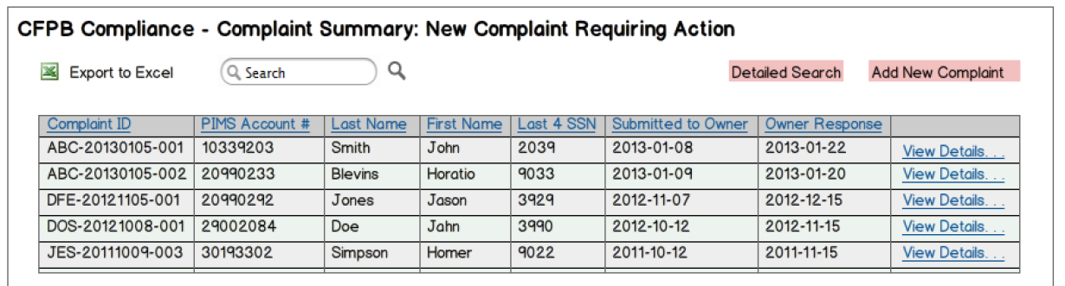

Figure 3: Agency New Complaint Requiring Action

### Agency Add New Consumer Complaint “Table Grid” Summary Fields

The execution of the search should look in PIMS for the associated information as well as in the MSI tables to see if there is an existing record of the desired account that is being searched on.

The “table grid” displayed when planning to add a new consumer complaint will include enough information to allow the Agency user to make the selection of the appropriate consumer that is filing the complaint. The columns on the “table grid” should enable the sorting of the table in ascending or descending order, and the “View Details . . .” link at the far right of the table should enable the Agency user to actually open the desired account to the “Add Complaint” screen as discussed below.

For the “Export to Excel” feature, all of the columns within both “Page 1” and “Page 2” of the search screens should be displayed in the associated excel file. The columns for this “table grid” should include the following:

* Complaint ID
* PIMS Account #
* Last Name
* First Name
* Last 4 SSN

## New Complaint Requiring Action

When a new complaint is entered into the system by the OWNER, it will remain in this queue of “New Complaint Requiring Action” until the Agency has actually accessed this account to begin working on it. Once the Agency user makes this selection from the “Compliance\CFPB Complaints\New Complaint Requiring Action” menu option, the “table grid” shown in the following figure will be presented with ONLY those accounts for the AGENCY that has actual accounts that have been entered into the system by the OWNER but have NOT been started to be worked by the Agency yet.

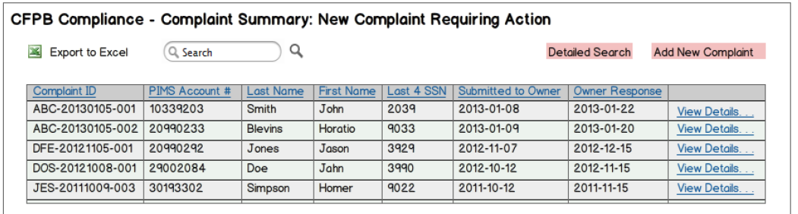

Figure 4: Agency New Complaint Requiring Action

The Agency user should have enough information when presented with this screen to select the appropriate record to open and update. If not, the Agency user will be able to use the “detailed search” search feature to filter the selected list of accounts to the specific one(s) to begin working on. Any “filtering” that the detailed search would perform would be on this already-reduced set of “New Complaints” only and not on all of the records in the database.

## New Complaint in Progress

When a new complaint is entered into the system by the Agency user, it will remain in this queue of “New Complaint in Progress” until the Agency has actually worked on the account and “submitted” it to the Owner for review. Once the Agency user makes this selection from the “Compliance\CFPB Complaints\New Complaint in Progress” menu option, the “table grid” shown in the following figure will be presented with ONLY those accounts for the AGENCY that has actual accounts that have been entered into the system but have NOT been submitted to the owner for review.

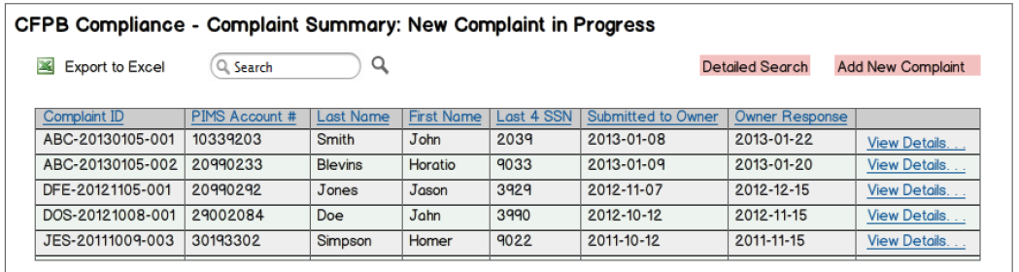

Figure 5: Agency New Complaint in Progress

The Agency user should have enough information when presented with this screen to select the appropriate record to open and update. If not, the Agency user will be able to use the “detailed search” search feature to filter the selected list of accounts to the specific one(s) to continue working on. Any “filtering” that the detailed search would perform would be on this already-reduced set of “New Complaints in Progress” only and not on all of the records in the database.

## Awaiting Additional Information

When a new complaint is entered into the system by the Agency user and the user has identified that there is additional information required from the debtor, the account will remain in this queue of “Awaiting Additional Information” until the debtor replies with the information as requested by the Agency. Once the Agency user makes this selection from the “Compliance\CFPB Complaints\Awaiting Additional Information” menu option, the “table grid” shown in the following figure will be presented with ONLY those accounts for the AGENCY that has actual accounts that are awaiting additional information from the debtor AND that have NOT been submitted to the owner for review.

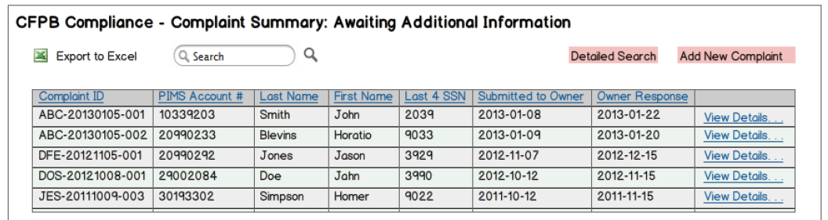

Figure 6: Agency Awaiting Additional Information

The Agency user should have enough information when presented with this screen to select the appropriate record to open and update. If not, the Agency user will be able to use the “detailed search” search feature to filter the selected list of accounts to the specific one(s) to continue working on once the appropriate information is received from the debtor. Any “filtering” that the detailed search would perform would be on this already-reduced set of “Complaints Awaiting Additional Information” only and not on all of the records in the database.

## Submitted for Owner Action

When a new complaint is entered into the system by the Agency user and has been submitted to the Owner for action, the account will remain in this queue of “Submitted for Owner Action” until the owner either requests additional information from the Agency, or replies with a closure response to the Agency. Once the Agency user makes this selection from the “Compliance\CFPB Complaints\Submitted for Owner Action” menu option, the “table grid” shown in the following figure will be presented with ONLY those accounts for the AGENCY that has actual accounts that are awaiting review and response by the Owner.

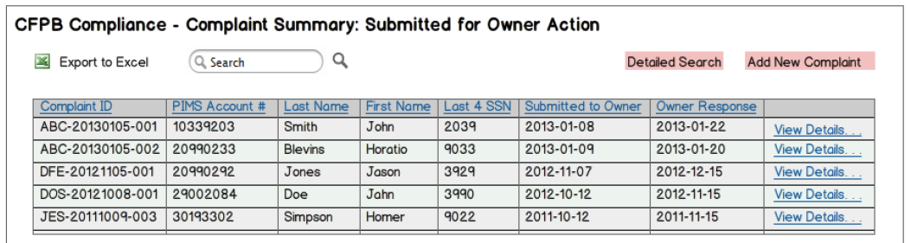

Figure 7: Agency Submitted for Owner Action

The Agency user should not have any real work to perform when viewing this set of records – it is more for the sake of knowing what records have been submitted to the Owner for action and are waiting in the queue for a response. In this manner, when a debtor makes a call to find out the status of their particular complaint, the Agency user would see that that their complaint may be sitting in this queue awaiting a response from the Owner.

## Owner Response in Progress

When a new complaint is entered into the system by the Agency user and has been submitted to the Owner for action and the Owner has at least OPENED the record to begin review, the account will remain in this queue of “Owner Response in Progress” until the owner either requests additional information from the Agency, or replies with a closure response to the Agency. Once the Agency user makes this selection from the “Compliance\CFPB Complaints\Owner Response in Progress” menu option, the “table grid” shown in the following figure will be presented with ONLY those accounts for the AGENCY that has actual accounts that are awaiting review and response by the Owner and have actually been looked at, but just not processed yet.

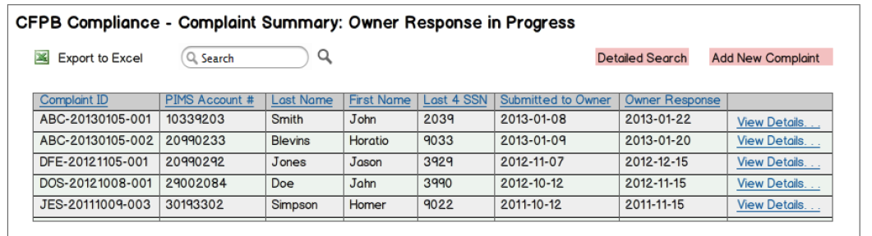

Figure 8: Agency view of Owner Response in Progress

The Agency user should not have any real work to perform when viewing this set of records – it is more for the sake of knowing what records have been submitted to the Owner for action and are waiting in the queue for a response. In this manner, when a debtor makes a call to find out the status of their particular complaint, the Agency user would see that that their complaint may be sitting in this queue awaiting a response from the Owner.

## Resolved Complaint

When a new complaint is entered into the system by the Agency user and has been submitted to the Owner for action, the Owner has updated the record with a response, and the satisfactory resolution has been determined and provided to the debtor, the complaint will be marked as “Resolved”. In the event that the Agency user wants to know if a particular complaint has been resolved [and what the resolution was], selecting the “Compliance\CFPB Complaints\Resolved Complaints” menu option will provide the “table grid” shown in the following figure. ONLY those accounts for the AGENCY that has actual accounts that have actually been resolved will be displayed.

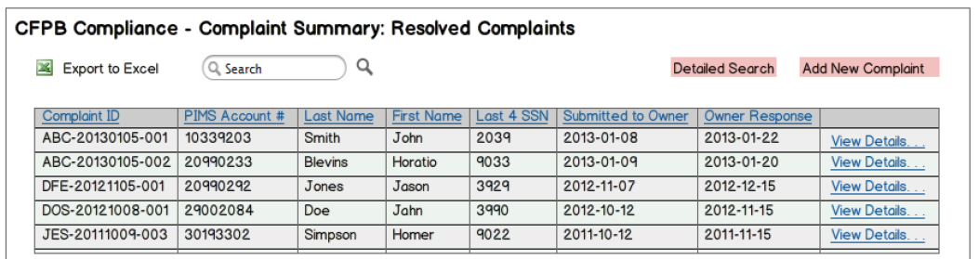

Figure 9: Agency Resolved Complaints

The Agency user should not have any real work to perform when viewing this set of records – it is more for the sake of knowing what records have been actually resolved. In this manner, when a debtor makes a call to find out the status of their particular complaint, the Agency user would see that that their complaint may actually be resolved and can inform them of that.

# Roles and User Access

This section describes roles associated with the Cascade Asset Management application as updated by this SOW.

## Cascade User

Initially, the “Cascade User” should have access to everything that is currently operational in the application [all modules and features, and all reports]. Additional roles will be determined during the coming weeks, but for now the distinction needs to be made between the “Cascade” user and the “Agency” user.

## Agency User

The “Agency User” should have limited access to those modules and reports as identified in the beginning of this document. Additional roles may be required as the system continues to be built, but for now the distinction needs to be made between the “Agency” user and the “Cascade” user.